


faculty of Computers and Artificial Intelligence
Beni-Suef University, Egypt

"Tutora Your Tour Guide For
Grand Egyptian Museum"

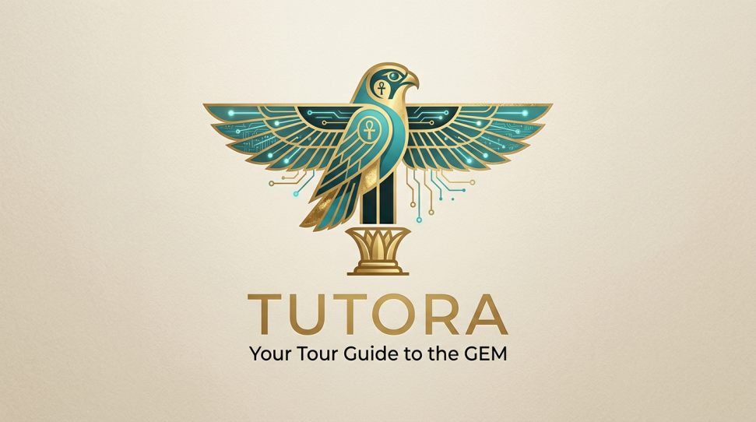
Presented by:
Abdelrhman Hassan
Ahmed Adel
Soad Atef
Sama Mahmoud
Sara Mahmoud
Aya Nasser
Rana Hamdy

Supervisor:
Prof.Dr: Hamdi Mahmoud
Assistant
Teaching Assistant: Eng. Mahmoud Khaled

Acknowledgment

First and foremost, we would like to express my deep and sincere appreciation to our supervisor, Prof.Dr (Hamdi Mahmoud) for giving us the great opportunity and strength to complete our Final Year Project under his guidance. His valuable suggestions, constructive advice, encouragements, and patience have helped us tremendously all the times during the planning and development of this project. He also provides a lot of feedback which increases the overall quality of this project. We truly appreciate his willingness to contribute his precious time to guide us with his professional knowledge and experience.
A very special thanks to Teaching Assistant (Eng. Mahmoud Khaled) for his kindness and generosity, we would not forget to remember him for his encouragement and more over for his timely support and guidance till the completion of our project work. He also provides a lot of feedback which increases the overall quality of this project. Besides, he also guided us by telling us how to build a good system. We would not have reached this phase, if it were not for his permanent support, advice, and guidance.
Furthermore, we are particularly grateful for the support and encouragement given by our family and friends throughout our entire Final Year Project. A million thanks to our parents who support us financially and emotionally. To our friends and classmates, thank you for providing advice and supporting us throughout this entire project.

Purpose of documentation
The purpose of the document is to collect and analyze all assorted ideas that have come up to define the system, its requirements with respect to consumers. Also, we shall predict and sort out how we hope this product will be used to gain a better understanding of the project, outline concepts that may be developed later, and document ideas that are being considered, but may be discarded as the product develops.

Briefly, the purpose of this document is to provide a detailed overview of our software and hardware products, its parameters, and goals. This document describes the project's target audience and its user interface, hardware, and software requirements. It defines how our client, team and audience see the product and its functionality. Nonetheless, it helps any designer and developer to assist in software delivery lifecycle (SDLC) processes.

Abstract

This work is organized as follows:
Chapter 1: addresses the overview of project, problems we have faced , objectives, and the impact of business.
Chapter 2: addresses the related work of our project and analyzes them carefully into features, benefits, Feasibility study, architecture, and components.
Chapter 3: addresses the project methodology, explains why this methodology was chosen, and concludes with a website block diagram that clarifies the system in a clear and centralized manner.
Chapter 4: addresses the project analyses and all its related diagrams as mind map, ERD, DFD, etc..
Chapter 5: addresses all the hardware details and diagrams in detail.
Chapter 6: describe the user interface of all parts of our system and testing phase of the system and user samples.
…………………………………………………………………………

List of Contents

- Chapter 1 (Introduction)
  - Introduction ……………………………………...……..………………..1
  - Problem Statement ………………………………………………………2
  - Objectives ………………………………………………………………..3
  - Software Development Lifecycle ………...……………………...............4
  - Impact in Business .……………………………...………………............6
  - Project Risk Management ………………………………………………7

- Chapter 2 (related works)
  - Introduction …………………………………………….……………..9
  - Related works ……………………....………….…..…...………….…9
  - Method of working the model ………………….…..…......…………13
  - Features ………………………………………………….……………14
  - Feasibility Study ……………………………...……………..………..15
  - Benefits ………………………………………...……………..………27
  - Project Risk Management………………………...………………...…28
  - Risk Management Process …………………………...………………28
  - Plan Risk Management ……………………………………………….29

- Chapter 3 (Project Methodology)
  - General definition and comparison …………………………………...30
  - Agile Model ………………....………………...……………………...32
  - Advantages of Agile Model ……………………………….………….32
  - Limitations of Agile Model …………………………………………..33
  - The properties of Agile Model….…………………………………….33
  - Rapid Application Development Model (RAD) ……………………...33
  - Advantages of RAD Model…………………………………………...34
  - Advantages of RAD Model…………………………………………...34
  - Chosen Methodology ………………………..…………...…………...35
  - Implementation (Final System) …….……………....………………...37

- Chapter 4 (Software Analysis and Design)
  - Project Requirement …………………...…………………………... 38
  - Project Mind Map ……………………..……………....….................42
  - Entity Relation Diagram …………..……………...……..………..…43
  - Project Software Tools and Technologies…………..…....………….49

- Chapter 5 (Device Analysis and Manufacturing)
  - Introduction …………………………………………………………57
  - Device hardware analysis …………………………………………..57
  - Microsoft Kinect SDK …………………………………………….. 58
  - LCD Advertising Screen………………………………………….....62
  - Basic Info……………………...………………………………….....63
  - Product Display…………………………….…………………….….64
  - Product Details …………………………….………………….……65
  - Product Functions ………………...……………………….………...66
  - Customize Service………………...…………………………………66
  - Product Functions ………………...…………………………………67

- Chapter 6 ( Interface Design & Testing )
  - Introduction …..…………...……………………....………………...68
  - System Database (Firebase)………………...……….........................68
  - Main Mobile Application (Flutter) …...……………....……………..70
  - Client Mobile Application (Flutter) …………………...…………….71
  - Testing user interface ……………………………..…………………76
  - Future Work …………………………………………….…..............88
  - Conclusion ……………………………..............................................89
  - Reference……………………………..………………..…………….90
…………………………………………………………………………

list of Tables

Table number Title page
Table 2.1 The research reports content summary 20
Table 2.2 Word frequency query results 21
Table 2.3 Cross tabulation of adv & dis adv of VFR types 25
Table 2.4 Cross tabulation of Sentiment toward 26
Table 4.1 Requirements of SDLC 39
Table 4.2 Versions Of Google Colaboratory 55
Table 4.3 Advantages & disadvantages of Google Colaboratory 56
Table 5.1 Basic Infor for LCD Advertising Screen 63
…………………………………………………………………………
list of Figures

Figure number Title page
Figure 1.1 Software Development Life Cycle 4
Figure 2.1 ACGPN Model Architecture 13
Figure 2.2 Pose Estimation Model 14
Figure 2.3 Cloning Image example 15
Figure 2.4 2D Virtual fitting Room 18
Figure 2.5 3D Virtual fitting Room 19
Figure 3.1 The Waterfall Model Phases 30
Figure 3.2 Agile Model process 32
Figure 3.3 Rapid Application Development Process 34
Figure 4.1 The Mind Map 42
Figure 4.2 The Context Diagram 43
Figure 4.3 Level 0 Diagram 44
Figure 4.4 The Use Case Diagram 45
Figure 4.5 The Sequence Diagram 46
Figure 4.6 The Activity Diagram 47
Figure 4.7 The Class Diagram 48
Figure 4.8 The State Diagram 49
Figure 4.9 Flutter Application Diagram 49
Figure 4.10 Bloc Management Diagram 50
Figure 4.11 Firebase Authentication Diagram 52
Figure 4.12 Cloud Firestore Diagram 53
Figure 4.13 Google Colaboratory Diagram 55
Figure 4.14 Microsoft Visio Diagram 56
Figure 5.1 Microsoft Kinect Camera 58
Figure 5.2 Hardware and Stream Provided 59
Figure 5.3 Kinect for Windows Developer Toolkit 60
Figure 5.4 Application Flow Chart 61
Figure 5.5 LCD Advertising Screen 62
Figure 5.6 Product Display 63
Figure 5.7 Product Details 64
Figure 5.8 Product Functions 65
Figure 5.9 Versions of Network 66
Figure 5.10 Types of Service 66
Figure 5.11 Size of Screens 67
…………………………………………………………………………

Chapter 1

Introduction

The Grand Egyptian Museum (GEM) stands as one of the most ambitious cultural and archaeological projects in the world, reflecting the grandeur of ancient Egyptian civilization in a modern architectural masterpiece. Located near the Giza Pyramids, the museum is designed to house over 100,000 artifacts, including the complete collection of King Tutankhamun, displayed together for the first time in history.
As one of Egypt’s most significant cultural landmarks, the museum is expected to attract millions of visitors annually, playing a crucial role in enhancing cultural tourism and preserving Egypt’s rich heritage. The museum offers a comprehensive narrative journey through different historical periods, presenting artifacts through chronological and thematic exhibitions supported by advanced display technologies.
With the rapid advancement of Artificial Intelligence technologies, there has been a global shift toward intelligent and interactive digital systems that enhance user experience and accessibility. Modern users increasingly seek personalized, real-time, and immersive ways to explore information, especially in cultural and educational contexts.
In response to this transformation, this project presents a web-based platform designed to serve as a smart digital tour guide for visitors of the Grand Egyptian Museum. The system aims to bridge the gap between ancient history and modern technology by providing an interactive and user-friendly environment that enhances engagement and learning.
The platform integrates advanced technologies such as Artificial Intelligence and 3D interactive visualization to deliver a rich and immersive experience, enabling users to explore artifacts in an engaging way while receiving intelligent assistance tailored to their needs.

1.2 Problem statement
Despite the importance of GEM, visitors face several challenges that affect their overall experience:
- Difficulty navigating the museum efficiently
- Limited access to detailed and interactive information about artifacts
- Lack of personalized guidance for understanding historical context
- No unified system combining booking, exploration, and learning
Enhancements Added:
- Data-driven example: "Surveys indicate that over 40% of museum visitors face difficulties in accessing detailed artifact information."
- Establishes a strong justification for a smart, interactive solution

1.3 Objectives
The main objective is to develop a smart, web-based system that improves the visitor experience at GEM. The system aims to:
- Provide an easy and efficient way to book tickets and plan visits
- Offer detailed and accessible information about artifacts and history
- Implement an AI-powered guide to assist users
- Integrate 3D interactive models for a more immersive experience
- Enable artifact detection and identification
- Provide chatbot support for user inquiries
- Include an online shop for purchasing museum-related products
- Enhance user engagement through interactive features such as the laboratory module
Enhancements Added (SMART Objectives):
- Reduce average online ticket booking time by 30% within 6 months
- Increase number of 3D artifacts displayed by 50% in initial deployment
- Improve user satisfaction by 25% through AI-guided interaction
- Enable accurate artifact identification with at least 90% success rate

1.4 Software Development Lifecycle

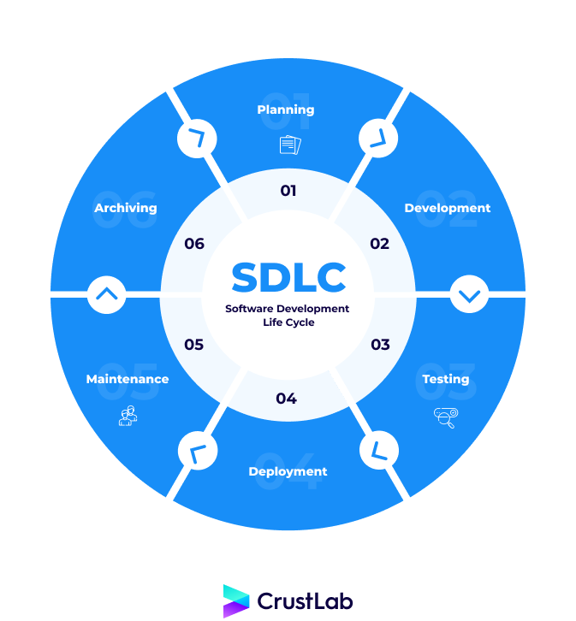
Software Development Life Cycle (SDLC) is a process used by the software industry to design, develop, and test HIGH-QUALITY software. The SDLC aims to produce a high-quality software that meets or exceeds customer expectations, reaches completion within times and cost estimates[8,9.10].
- SDLC is the abbreviation of Software Development Life Cycle.
- It is also called the Software Development Process.
- SDLC is a framework defining tasks performed at each step in the software development process.
- ISO/IEC 12207 is an international standard for software life-cycle processes. It aims to be the standard that defines all the tasks required for developing and maintaining software.
Figure 1.1: Software Development Life Cycle

Stage 1: Planning and Requirement Analysis
In this stage, the project objectives were defined, focusing on developing a smart digital platform to enhance the experience of visitors at the Grand Egyptian Museum.
The team conducted several meetings to discuss the project idea, define the scope, and distribute tasks among members to ensure effective collaboration.
Additionally, a field visit to the museum was carried out to collect real-world data and better understand the environment, artifact presentation, and visitor needs. This helped in identifying suitable features such as interactive tours and AI-based assistance.
A feasibility study was also performed to evaluate the technical and operational aspects of integrating AI and 3D technologies into the system.
Stage 2: Defining Requirements
In this stage , the system requirements were clearly defined and documented based on the analysis phase.
Functional requirements included enabling users to explore artifacts digitally, book tickets online, interact with an AI-powered chatbot and virtual guide, and use advanced features such as 3D models and artifact detection through images. These features were selected to enhance user engagement and provide an interactive learning experience.
Non-functional requirements focused on ensuring high system performance, fast response time, ease of use, and data security. The system was also designed to be scalable, allowing it to handle a large number of users simultaneously, especially during peak visiting periods.

Stage 3: Designing the Product Architecture
During this stage the overall system architecture was designed to organize and connect all system components effectively.
The design included creating a user-friendly front-end interface, a robust back-end system to handle data processing and APIs, and a well-structured database to store users, artifacts, bookings, and transactions. The integration of AI modules such as the chatbot and recommendation system was carefully planned.
Additionally, the structure for 3D visualization and interactive features was designed to ensure smooth performance and usability. This stage resulted in a clear blueprint that guided the development process and ensured consistency across the system.

Stage 4: Building or Developing the Product
In this phase, the system was implemented based on the previously defined design.
The team collaborated to develop both front-end and back-end components, ensuring proper integration between different parts of the system. AI features such as the chatbot and recommendation system were implemented, along with 3D models to allow users to explore artifacts interactively.
Additional modules, including the interactive lab and artifact detection system, were also developed to provide a unique and engaging user experience. Version control systems were used to manage the code, track progress, and support effective teamwork among team members.
Stage 5: Testing the Product
In this stage, the system was thoroughly tested to ensure it meets all functional and non-functional requirements.
Various testing methods were applied, including functional testing to verify system features, usability testing to ensure ease of use, and performance testing to evaluate system speed and responsiveness. Security testing was also conducted to protect user data and ensure safe interactions within the platform.
The team collected feedback from testing and made necessary improvements, fixing bugs and enhancing system stability and overall performance.

Stage 6: Deployment in the Market and Maintenance
After successful testing, the system was deployed as a web-based platform accessible to users.
The deployment process ensured that all system components were properly integrated and functioning in a real environment. After deployment, the team continuously monitored system performance and addressed any issues that arose.
Regular updates were applied to improve features, enhance user experience, and optimize system efficiency. The team also worked on refining AI functionalities and interactive modules based on user feedback, ensuring continuous system improvement.

1.5 Impact in Business
The project has significant implications both for users and for GEM's business operations:
User Perspective:
- Provides an interactive and informative experience
- Improves accessibility to cultural content
- Increases engagement through AI and 3D modules
Business Perspective:
- Increase online ticket sales
- Boost revenue via online shop
- Improve customer satisfaction and retention
- Promote Egyptian cultural heritage globally
- Support digital transformation in the tourism sector
Enhancements Added:
- Suggested KPIs for measurement:
  - Number of online bookings per month
  - Active users on the platform
  - Average engagement time with 3D content
  - Customer satisfaction survey results

1.6 Project Risk Management

Risk management is an essential part of any software project. It involves identifying potential risks, analyzing their impact, and developing strategies to minimize or eliminate them.
Some potential risks in this project include:
- Technical challenges in integrating AI and 3D features
- Security issues related to user data and online payments
- Performance issues under high user traffic
- Possible delays in development
To mitigate these risks, proper planning, continuous testing, and the use of reliable technologies are implemented throughout the development process.
…………………………………………………………………………

Chapter 2
2.1 Introduction
This chapter reviews existing systems, studies, and technologies relevant to the Grand Egyptian Museum web platform. It provides a comprehensive understanding of previous work in museum digitalization, AI-based tour guides, 3D interactive systems, and online booking platforms. The aim is to identify best practices, gaps, and opportunities to improve the design and functionality of our system.

2.2 Related Work:
Several studies and projects have focused on enhancing museum experiences through digital technology. Key examples include:
- The Louvre Virtual Tour (France): Offers 360-degree panoramic views, high-resolution images, and detailed descriptions of major exhibits. It allows remote visitors to explore iconic artifacts and has been widely used for educational purposes.
- The Smithsonian AI Guide (USA): An AI-powered virtual assistant that answers visitor questions, provides personalized recommendations, and offers interactive learning modules. Studies show it increases visitor engagement and knowledge retention.
- The British Museum 3D Models (UK): Provides interactive 3D models of artifacts and historical figures. Users can rotate, zoom, and explore details, enhancing understanding of the cultural context.
- The MET Online Ticketing and Shop (USA): Integrates online ticketing and e-commerce, improving visitor convenience and access to museum services.
- Digital Tutankhamun Exhibition (Egypt): A virtual tour featuring 3D scans of Tutankhamun’s artifacts. Highlights the importance of combining high-quality 3D models with storytelling to engage international audiences.
- Research by Ioannides et al., 2021: Shows that AI-driven museum guides significantly improve visitor satisfaction, learning, and interactivity, especially when integrated with augmented reality (AR) or 3D visualization.
By analyzing these works, our platform adopts the most effective features while addressing existing limitations, such as limited personalization, insufficient engagement, and lack of dynamic storytelling. Unlike standard virtual tours or AI guides, our system combines:
- AI-powered artifact detection to identify objects in real-time
- Dynamic storytelling for each artifact using LLMs
- Interactive 3D visualization
- A laboratory module for creative, culturally inspired activities
- Integrated ticketing and e-commerce
This combination ensures a fully immersive, educational, and personalized experience, bridging ancient history with modern technology.

2.3 Method of working of the model
The system employs a modular approach to integrate all functionalities seamlessly. The main steps include:
- User Interaction Module: Handles registration, login, ticket booking, and profile management.
- Artifact Exploration Module: Displays artifacts, provides detailed descriptions, and enables 3D interactions.
- AI Guide Module: Uses artificial intelligence to answer user queries and provide personalized suggestions.
- Laboratory Module: Allows users to write names in hieroglyphics, transform pictures into Pharaoh characters, and create custom designs inspired by ancient Egyptian art.
- Payment and Shop Module: Manages online transactions and purchases from the museum shop.
Each module communicates through a centralized web system ensuring smooth and efficient operation.
2.4 Features
The proposed system provides a set of advanced and interactive features designed to enhance the user experience and engagement with the Grand Egyptian Museum platform. These features include:
- AI Tour Guide and Chatbot
An intelligent chatbot powered by Large Language Models (LLMs) that interacts with users, answers questions, and provides personalized guidance throughout the system.
- Artifact Detection Model
A computer vision-based model that allows users to upload or capture an image of a statue or artifact, then automatically identifies it and displays its name and related information.
- Dynamic Story Generation (LLM)
A text generation model that produces a unique historical narrative about the selected artifact each time, ensuring a dynamic and engaging user experience.
- Text-to-Speech (TTS) Model
Converts the generated textual content into audio, allowing users to listen to artifact stories in an interactive way.
- Static Video Presentation
Displays a pre-designed video with historical background visuals synchronized with the generated audio to enhance storytelling.
- Hieroglyphic Name Generator
A feature that transforms the user’s name into its equivalent representation in ancient Egyptian hieroglyphics.
- Image Generation from Story
A generative AI model that converts a user-provided story or description into a visual image inspired by ancient Egyptian art.
- Pharaoh Style Image Transformation
A model that transforms a user’s uploaded image into a pharaoh-style portrait, reflecting ancient Egyptian appearance.
- Artifact Similarity Model
A recommendation model that, given a specific artifact, retrieves the top five most similar artifacts based on dynasty, historical period, and visual features.
2.5 Feasibility Study
1.Introduction
This feasibility study evaluates the practicality, effectiveness, and benefits of implementing the Grand Egyptian Museum web platform.
2. Idea and types of Implementation
The project uses a web-based solution with AI, 3D modeling, and interactive modules. The system can be accessed on desktops, laptops, and mobile devices.
3 Findings of the study
3.1 Content analysis
The study shows that visitors prefer interactive and engaging digital content over static text-based information. 3D models and AI interaction significantly increase user engagement.
3.2 Sentiment analysis
User feedback from similar digital museum platforms indicates positive sentiment towards interactive and personalized experiences, while emphasizing the importance of usability and accessibility.

4.Conclusion
The feasibility study confirms that a web-based AI and 3D interactive platform is viable, practical, and beneficial for both visitors and museum management.
2.6 Benefits
- Enhances visitor engagement and learning
- Improves accessibility to museum content
- Increases ticket sales and online shopping revenue
- Promotes Egyptian cultural heritage globally
- Provides a modern and user-friendly interface
2.7 Project Risk Management
The project faces potential risks such as:
- Technical challenges in AI and 3D integration
- Security and privacy issues related to user data
- Performance issues under high traffic
- Possible delays in development
2.8 Risk Management Process
To mitigate risks, the following steps are taken:
- Continuous monitoring of development progress
- Regular testing of system modules
- Secure handling of user data and payments
- Backup and recovery procedures for system failures
2.9 Plan Risk management:
- Identify potential risks at early stages
- Assess impact and probability of each risk
- Develop preventive measures and contingency plans
- Monitor and update risk management strategies throughout the project lifecycle
…………………………………………………………………………

chapter 3

3.1 General definition and comparison
- ………………….

3.2 Agile Model:
………………

3.3 Advantages of the Agile Model:
- …………………

3.4 Limitations of Agile Model
- …………………
3.5 The properties of Agile Model:
- ……………..

3.6 RAD model:
………….
Figure 3.3 : Rapid Application Development Process
3.7 Advantages of RAD Model:
- ……………..
3.8 Disadvantages of RAD Model:
- ……………

3.9 Chosen Methodology
…………………..
Stage 1- Planning
……………..

Stage 2- Design
…………

3.10 Implementation (Final System)
…………………….

chapter 4
4.1 Requirements:
Define the function of the system from the client's viewpoint:
- The requirements establish the system’s functionality, constraints, and goals by consultation with the customers and users.
- The requirements may be developed in self-contained study or may emerge incrementally.
- The requirements from the basis for acceptance testing.
- The development team and client need to work together closely during requirements phases of the software project.
- The requirements must be developed in a manner that is understandable by both the client and the development staff.
Requirement Goals:
- Understand the requirements in appropriate detail.
- Define requirements in a manner that is clear to the client. This may be a written specified prototype system, or other form of communication.
- Define requirements in a manner that is clear to people who will design, implement, and maintain the system.
- Ensure that the client and developers understand requirements and their implications.
Functional Requirements:
Describe the functions that the system must perform. They are identified by analyzing the use made of the system and include topics such as:
- Functionality.
- Data.
- User interfaces.
Non-Functional Requirements:
Requirements that are not directly related to the functions that the system must perform.
- Product requirements
- Performance, reliability, portability, etc.….
- Organizational requirements
- Delivery, training, standards, etc.…….
- External requirements
- Legal, interoperability, etc.…….
- Marketing and public relations.
Table 4.1 : Requirements of SDLC
ID | Requirements | Date | Related Requirements | Related stockholders | Type (Functional /Non-Functional
1 | Overview | 2/11  /2021 | 1.quick search for tools  2.deep search for tools and how use it | Developers | Functional
2 | System interface | 5/11  /2021 | 1.operation system: Linux, Mac, Windows  2.Development: PHP, CSS, JavaScript, python  3.Database: MySQL | Developers | Functional
3 | Distribution of tasks | 20/11/2021 | 1.define main tasks  2. Divide tasks into smaller tasks  3. Giving developers the appropriate task | Leader | Functional
4 | Manage the Admin’s registration process | 22/11/2021 | 1.create registration system  2.create admin’s data input form  3.updating  4.Ensure complete process correctly | Admin | Functional
5 | Data base | 1/12  /2021 | 1.create an account in firebase  2.determine the memory | Leader | Functional
6 | Manage Model process | 1/1  /2022 | 1.define the model functionality  2.tools of the model  3.create the model  4.Ensure the model work correctly | Developers | Functional
7 | UI design | 16/1  /2022 | 1.search for templets  2.sketch the ui templet  3.sketch the suitable screens, icons, buttons for the project | Designer | Functional
8 | Manage the app process | 22/1  /2022 | 1.define the main functions will added to the app  2.define programming language it will use  3.create the first version  4.test app and create the final version | Developers | Functional
9 | Add new item | 12/2  /2022 | 1.create product data input form  2.Ensure data is correct  3.save it in the firebase | Admin | Functional
10 | Camera | 14/2  /2022 | 1.get detect request from user  2.open camera and get pic  3.use it by but clothes on image | Admin | Functional
11 | Manage the Admin’s Home | 15/2  /2022 | 1.create admin’s home form  2.create admin’s data input form  3.Ensure admin’s home data | Amin | Functional
12 | Manage the integration process | 25/2  /2022 | 1.Ensure the model process is work correctly  2.Ensure the app is work correctly  3.integrate between the app and the model  4.Ensure the integration is correctly | Developers | Functional
13 | Solving problems | 27/2/2022 | 1.determine the errors  2.search for solution  3.solving errors | Developers | Functional
14 | Testing process | 1/3/2022 | 1.testing the software model code  2.testing the app software code  3.test the integration  4.get final version | Developers | Functional
15 | Performance | 1/4/2022 | 1.easy to get product and make user try it  2.updating can be done  3.process didn’t take long time | Admin | Non- Functional

4.2. Mind Map of Project
Mind Mapping is an effective tool for taking information from your brain and putting it on paper for a variety of reasons or for scribing new data coming into your brain. Brainstorming, organizing, requirements gathering, decision making, and planning are just a few of the many applications for Mind Mapping.
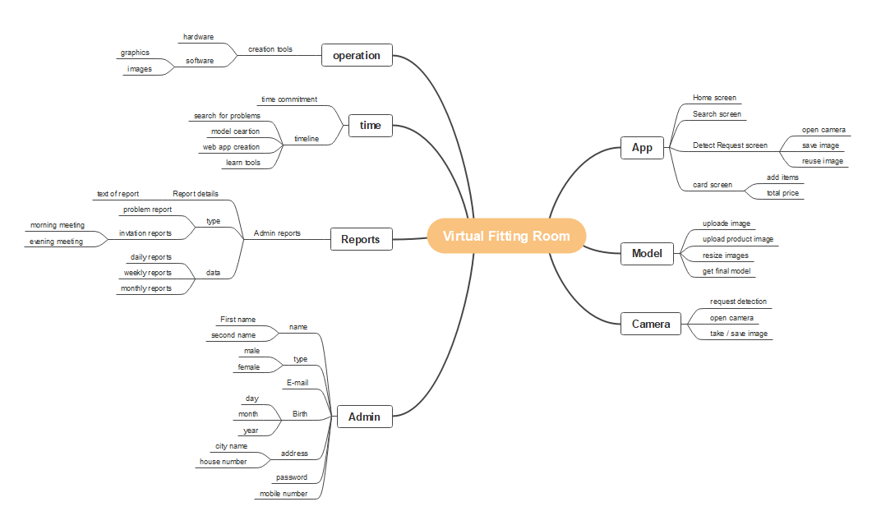
Figure 4.1 : The Mind Map

4.3 Entity Relation Diagrams
4.3.1 Context Diagram
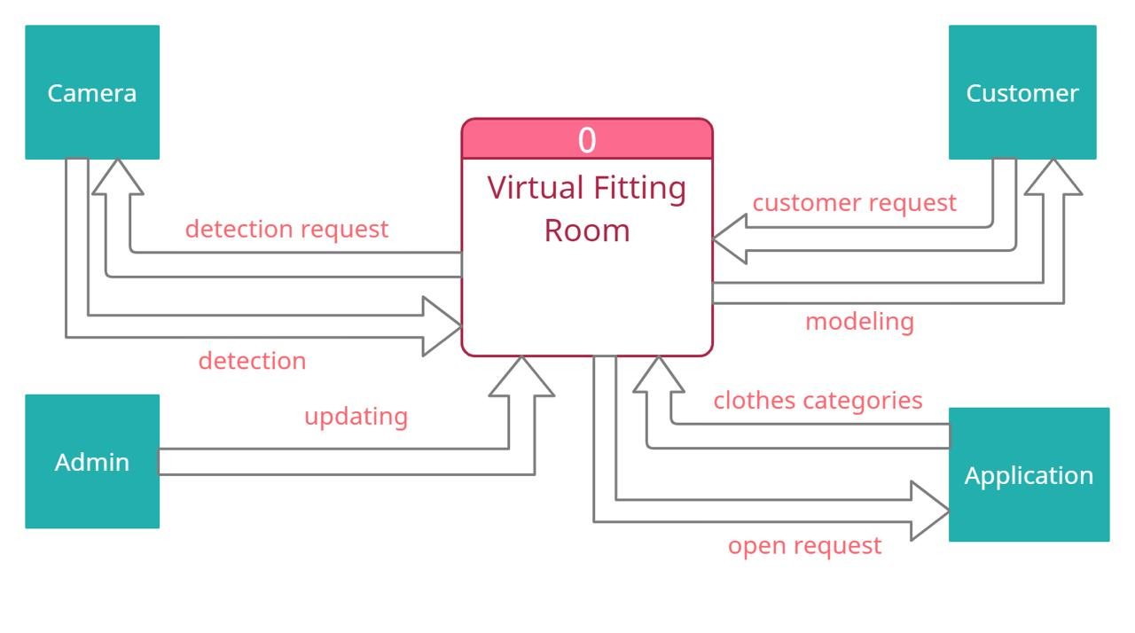
Context diagrams show the interactions between a system and other actors (external factors) with which the system is designed to interface.
Figure 4.2 : The Context Diagram

4.3.2 Level 0
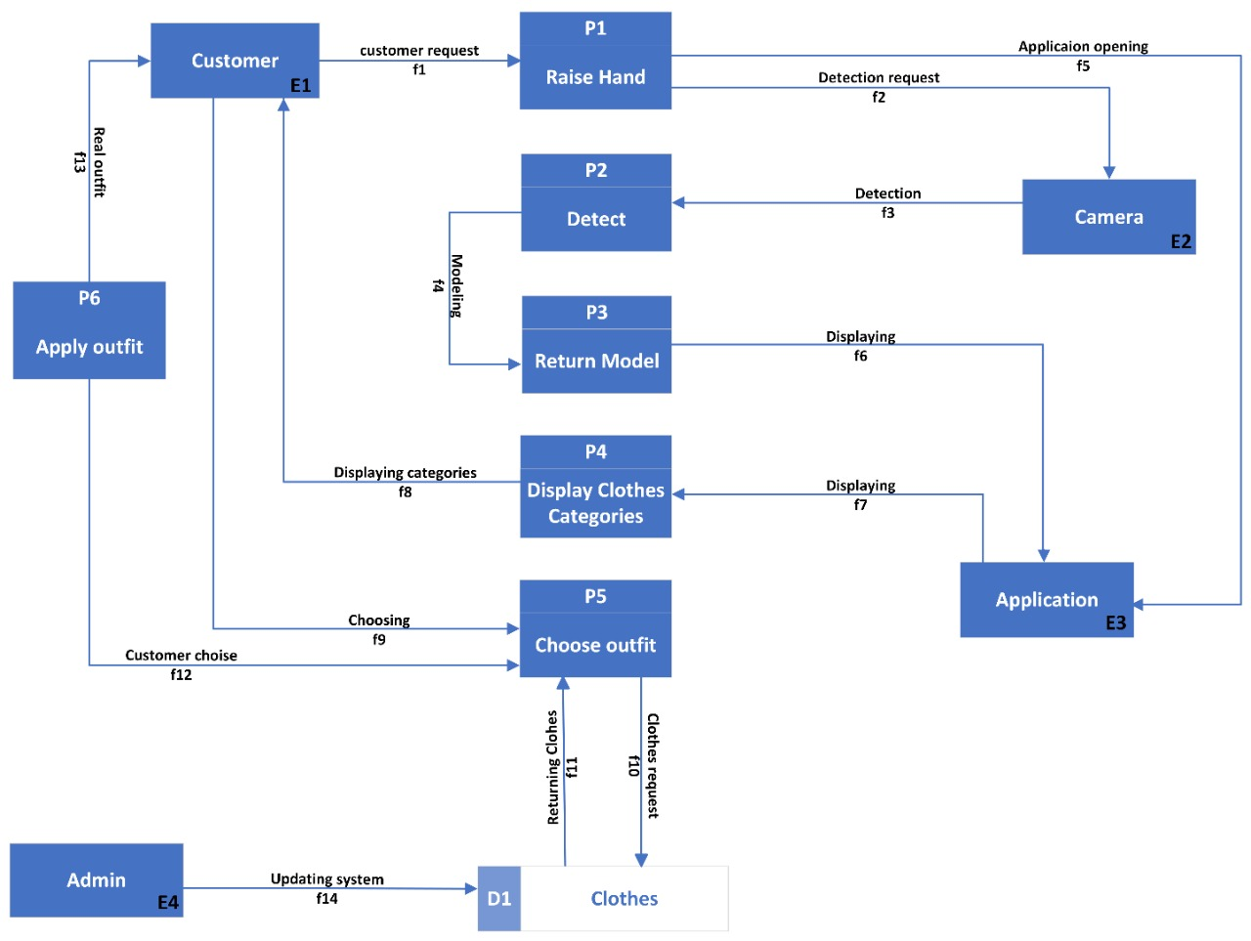
Level 0 is also called a Context Diagram. It's a basic overview of the whole system or process being analyzed or modeled. It's designed to be an at-a-glance view, showing the system as a single high-level process, with its relationship to external entities.
Figure 4.3 : Level 0 Diagram
4.3.3 Use Case Diagram
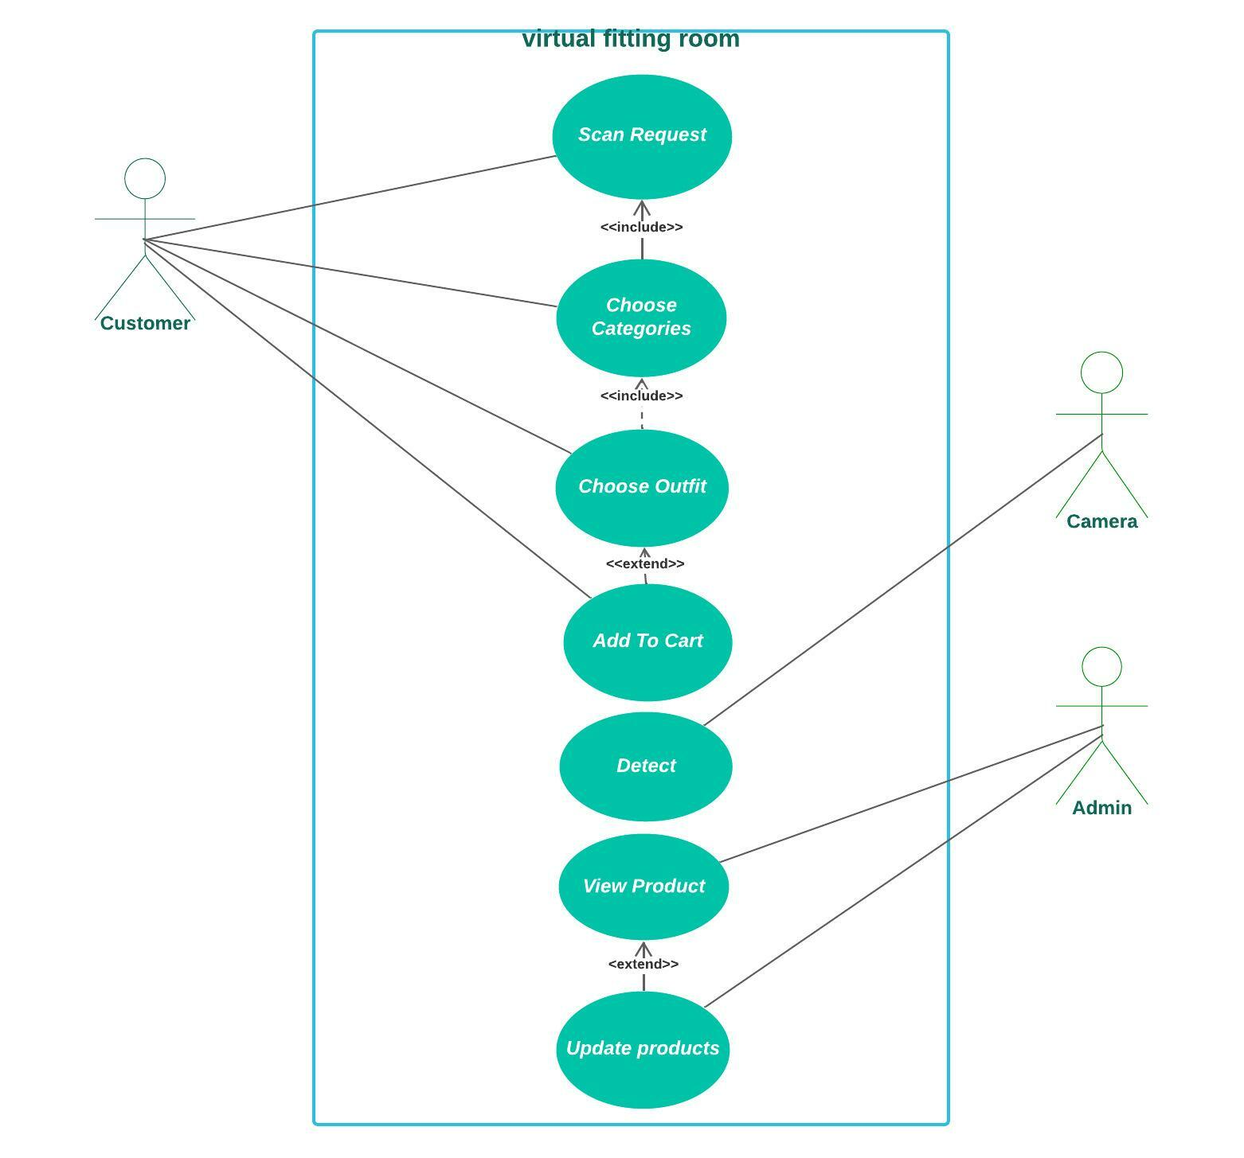
use case diagram is the primary form of system/software requirements for a new software program underdeveloped. Use cases specify the expected behavior (what), and not the exact method of making it happen (how). Use cases once specified can be denoted both textual and visual representation.
Figure 4.4 : The Use Case Diagram

4.3.2 Sequence Diagram
A sequence diagram is a type of interaction diagram because it describes how—and in what order—a group of objects works together.

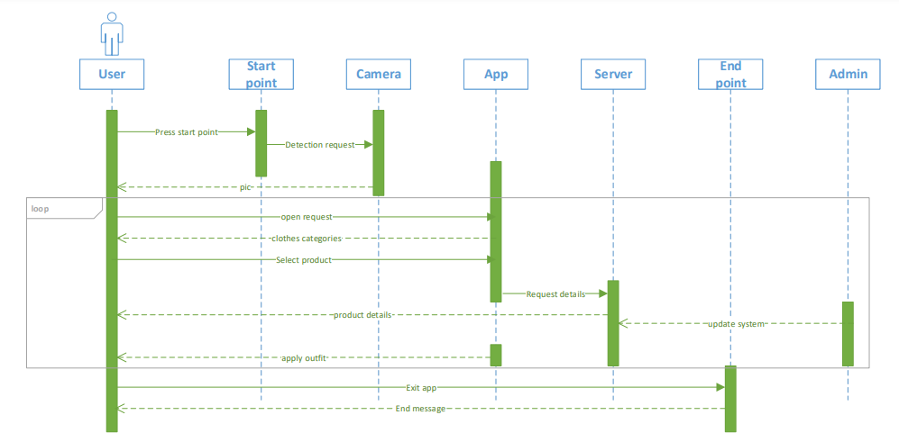
Figure 4.5 : The Sequence Diagram

4.3.4 Activity Diagram
An activity diagram visually presents a series of actions or flow of control in a system similar to a flowchart or a data flow diagram. Activity diagrams are often used in business process modeling.
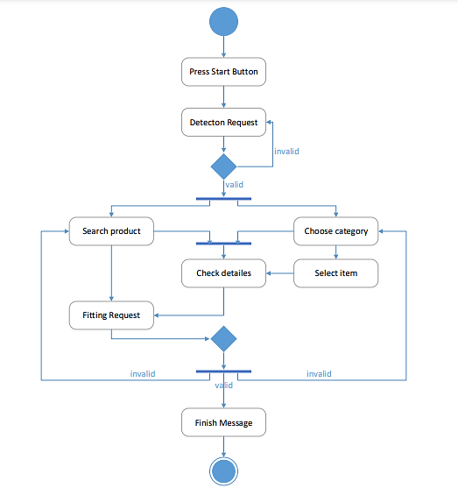
Figure 4.6 : The Activity Diagram

4.3.5 Class Diagram
a class diagram in the Unified Modeling Language (UML) is a type of static structure diagram that describes the structure of a system by showing the system's classes, their attributes, operations (or methods), and the relationships among objects.
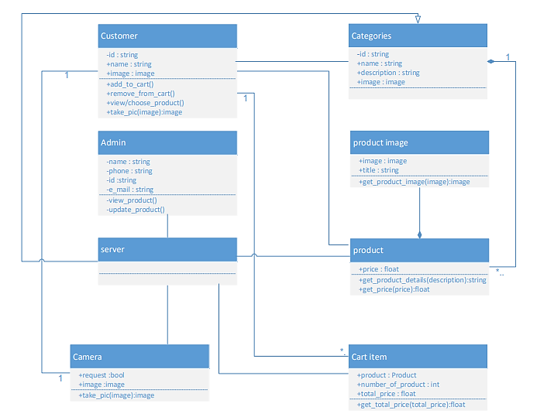

Figure 4.7 : The Class Diagram

4.3.6 State Diagram
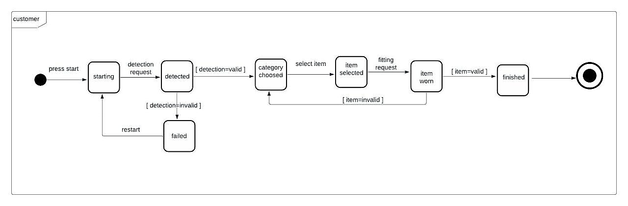
A state diagram is a type of diagram used in computer science and related fields to describe the behavior of systems.
Figure 4.8 : The State Diagram

4.4 Project Software tools and Technology
………

4.4.1 Made by Google
Flutter is Google’s UI toolkit for building beautiful, natively compiled applications for mobile, web, and desktop from a single codebase. Flutter is an open-source UI software development kit created by Google. It is used to develop applications for Android, iOS, Linux, Mac, Windows, Google Fuchsia and the web from a single codebase.
The first version of Flutter was known as codename "Sky" and ran on the Android operating system. It was unveiled at the 2015 Dart developer summit, with the stated intent of being able to render consistently at 120 frames per second. During the keynote of Google Developer Days in Shanghai, Google announced Flutter Release Preview 2 which is the last big release before Flutter 1.0.
On December 4, 2018, Flutter 1.0 was released at the Flutter Live event, denoting the first "stable" version of the Framework. On December 11, 2019, Flutter 1.12 was released at the Flutter Interactive event.
On May 6, 2020, the Dart SDK in version 2.8 and the Flutter in version 1.17.0 were released, where support was added to the Metal API, improving performance on iOS devices (approximately 50%), new Material widgets, and new network tracking tools.
Flutter State Management Pattern
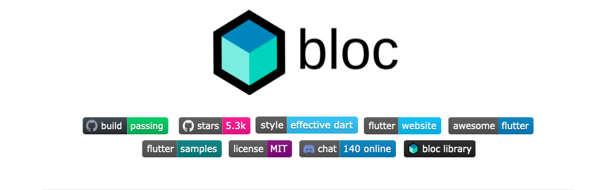
Figure 4.10 : Bloc Management Diagram

Bloc makes it easy to separate presentation from business logic, making your code fast, easy to test, and reusable.
When building production quality applications, managing state becomes critical.
As developers we want to:
- know what state our application is in at any point in time.
- easily test every case to make sure our app is responding appropriately.
- record every single user interaction in our application so that we can make data-driven decisions.
- work as efficiently as possible and reuse components both within our application and across other applications.
- have many developers seamlessly working within a single code base following the same patterns and conventions.
- develop fast and reactive apps.
Bloc was designed to meet all of those needs and many more.
There are many state management solutions and deciding which one to use can be a daunting task.
Bloc was designed with three core values in mind:
- Simple
- Easy to understand & can be used by developers with varying skill levels.
- Powerful
- Help make amazing, complex applications by composing them of smaller components.
- Testable
- Easily test every aspect of an application so that we can iterate with confidence.
Bloc attempts to make state changes predictable by regulating when a state change can occur and enforcing a single way to change state throughout an entire application.

4.4.2 Firebase
Firebase is a Backend-as-a-Service (BaaS) app development platform that provides hosted backend services such as a Realtime database, cloud storage, authentication, crash reporting, machine learning, remote configuration, and hosting for your static files.
Firebase evolved from Envolve, a prior startup founded by James Templin and Andrew Lee in 2011. Envolve provided developers an API that enables the integration of online chat functionality into their websites.
After releasing the chat service, Templin and Lee found that it was being used to pass application data that were not chat messages. Developers were using Evolve to sync application data such as game state in real time across their users. Templin and Lee decided to separate the chat system and the real-time architecture that powered it. They founded Firebase as a separate company in September 2011 and it launched to the public in April 2012.
Firebase Authentication
Firebase Authentication aims to make building secure authentication systems easy, while improving the sign-in and onboarding experience for end users. It provides an end-to-end identity solution, supporting email and password accounts, phone auth, and Google, Twitter, Facebook, and GitHub login, and more.


Figure 4.11 : Firebase Authentication Diagram

IOS Android Web. Firebase SDK Authentication. Email and password-based authentication. Authenticate users with their email addresses and passwords. The Firebase Authentication SDK provides methods to create and manage users that use their email addresses and passwords to sign in.
To sign a user into your app, you first get authentication credentials from the user. These credentials can be the user's email address and password, or an OAuth token from a federated identity provider. Then, you pass these credentials to the Firebase Authentication SDK. Our backend services will then verify those credentials and return a response to the client.
After a successful sign in, you can access the user's basic profile information, and you can control the user's access to data stored in other Firebase products. You can also use the provided authentication token to verify the identity of users in your own backend services.
Firebase Realtime Database
Cloud Fire store is a NoSQL document database that lets you easily work with data at a

global scale. This course will teach you the basics of Cloud Fire store, including basic syntax, adding, managing, querying, and securing data.
Figure 4.12 : Cloud Firestore Diagram

Key features of Cloud Fire store include:
- Documents and collections with powerful querying
- iOS, Android, and Web SDKs with offline data access
- Real-time data synchronization
- Automatic, multi-region data replication with strong consistency
- Node, Python, Go, and Java server SDKs

And of course, we've aimed for the simplicity and ease-of-use that is always top priority for Firebase, while still making sure that Cloud Fire store can scale to power even the largest apps. Managing app data is still hard; you must scale servers, handle intermittent connectivity, and deliver data with low latency.
Cloud Fire store optimized for app development, so you can focus on delivering value to your users and shipping better apps, faster. Cloud Fire store:
- Synchronizes data between devices in real-time. Our Android, iOS, and JavaScript SDKs sync your app data almost instantly. This makes it incredibly easy to build reactive apps, automatically sync data across devices, and build powerful collaborative features -- and if you don't need real-time sync, one-time reads are a first-class feature.
- Uses collections and documents to structure and query data. This data model is familiar and intuitive for many developers. It also allows for expressive queries. Queries scale with the size of your result set, not the size of your data set, so you'll get the same performance fetching 1 result from a set of 100, or 100,000,000.
- Enables offline data access via a powerful, on-device database. This local database means your app will function smoothly, even when your users lose connectivity. This offline mode is available on Web, iOS, and Android.
- Enables serverless development. Cloud Fire store’s client-side SDKs take care of the complex authentication and networking code you'd normally need to write yourself. Then, on the backend, we provide a powerful set of security rules so you can control access to your data. Security rules let you control which users can access which documents, and let you apply complex validation logic to your data as well. Combined, these features allow your mobile app to connect directly to your database.
- Integrates with the rest of the Firebase platform. You can easily configure Cloud Functions to run custom code whenever data is written, and our SDKs automatically integrate with Firebase Authentication, to help you get started quickly.

4.4.3 Google Colaboratory

It is a cloud service based on Jupiter Notebooks. Collab allows anyone to write and execute arbitrary Python code through the browser, and is particularly suitable for machine learning, deep learning, data analysis, and education. Since Collab is a Jupiter-hosted laptop service that requires no setup to use, while providing free access to computing resources including CPUs, GPUs, and TPUs.
Figure 4.13 : Google Colaboratory Diagram
As a programmer, you can perform the following using Google Collab.
- Write and execute code in Python.
- Document your code that supports mathematical equations.
- Create/Upload/Share notebooks.
- Import/Save notebooks from/to Google Drive.
- Import/Publish notebooks from GitHub.
- Import external datasets e.g., from Kaggle.
- Integrate PyTorch, TensorFlow, Keras, OpenCV.
- Free Cloud service with free GPU.
Collab Versions:
Table 4.2 : Versions of Google Colaboratory
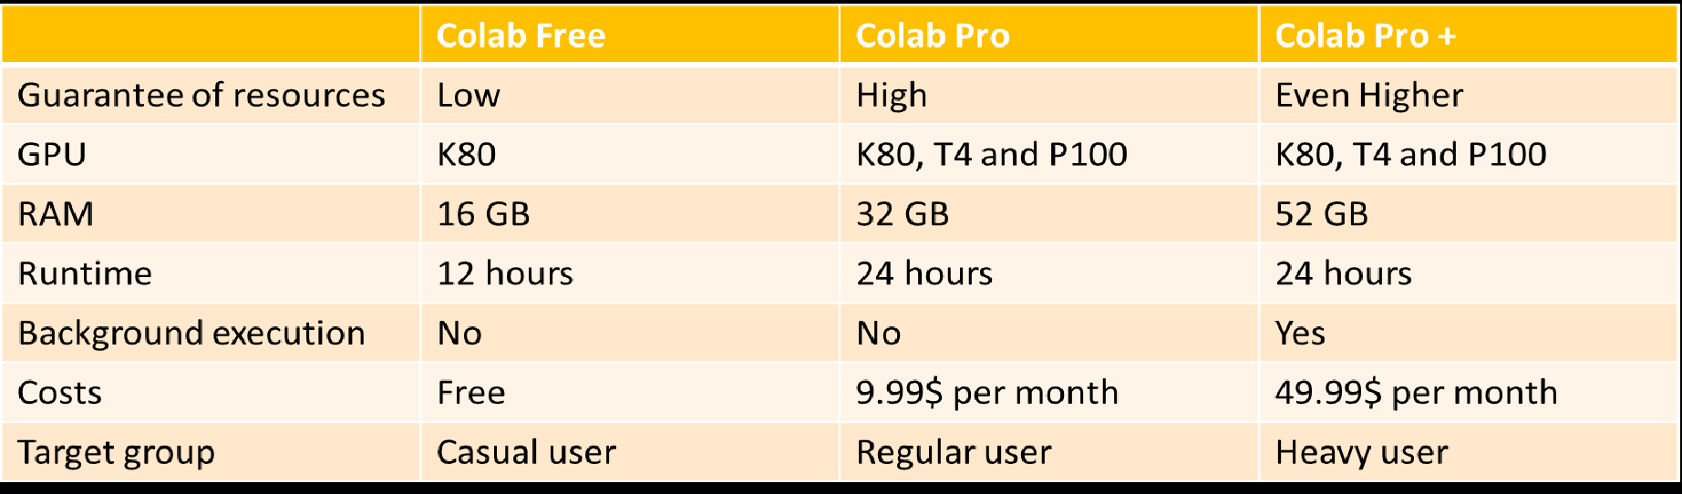

Advantages & Disadvantages:

Advantages | Disadvantages
It is a powerful platform for learning and quickly developing machine learning models in Python. | It does not support R or Scala yet.
Colab excels at being super-efficient in sharing, scrolling, and organizing code. | There is also a limitation to sessions and size.
No required to setup infrastructure | It is too bad if you ‘ve slow internet.
It doesn’t compile libraries on every run, just once. | It is too bad if you ‘ve slow internet.
It is faster computation because it has 8 – 16 GB RAM. | It has no persistent storage; Google drive has 15 GB data limit.
It provides free GPU and support the pip and apt package managers. | There's no live editing which means lots of up and back sharing for teams.
Table 4.3 : Advantages & disadvantages of Google Colaboratory

4.4.4 Visio

Microsoft Visio is software for drawing a variety of diagrams. These include flowcharts, org charts, building plans, floor plans, data flow diagrams, process flow diagrams, business process modeling, swim lane diagrams, 3D maps, and many more. It's a Microsoft product, sold as an addition to MS Office.


Figure 4.14 : Microsoft Visio Diagram

CHAPTER 5

.

Chapter 6

6.1 Introduction

6.6 Future Work
…………………..

6.7 Conclusion
…………..

6.8 Reference

[1] T.Ramaprabha & M.Mohamed, S., “The efficiency enhancement in non immersive virtual reality system by haptic devices,” International Journal Of Advanced Research in Computer Science and Software Engineering, 2(3), 2012.

